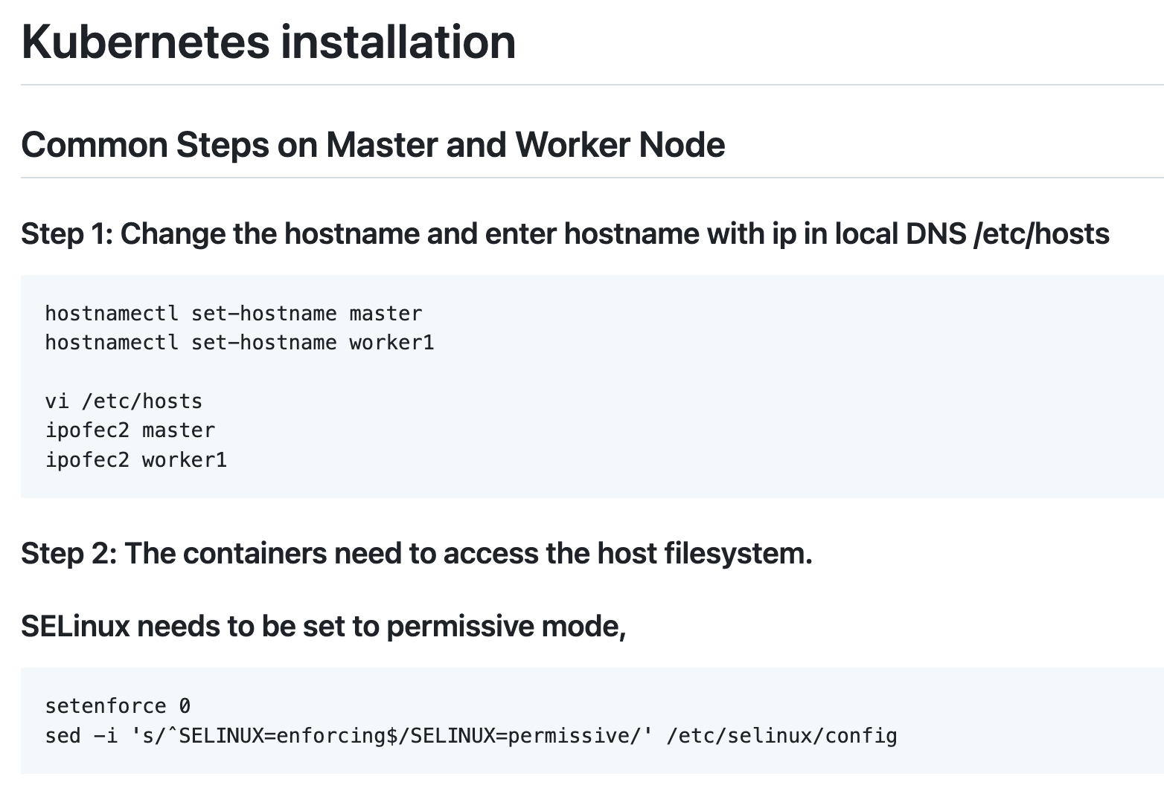

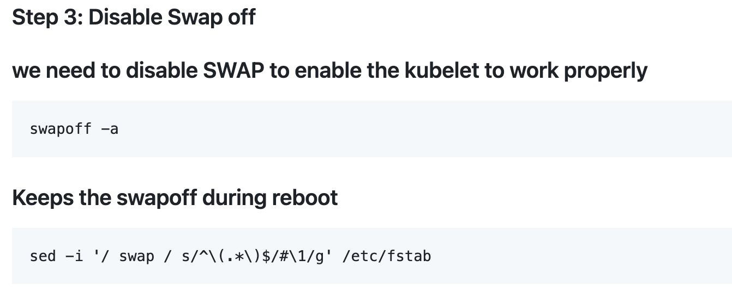

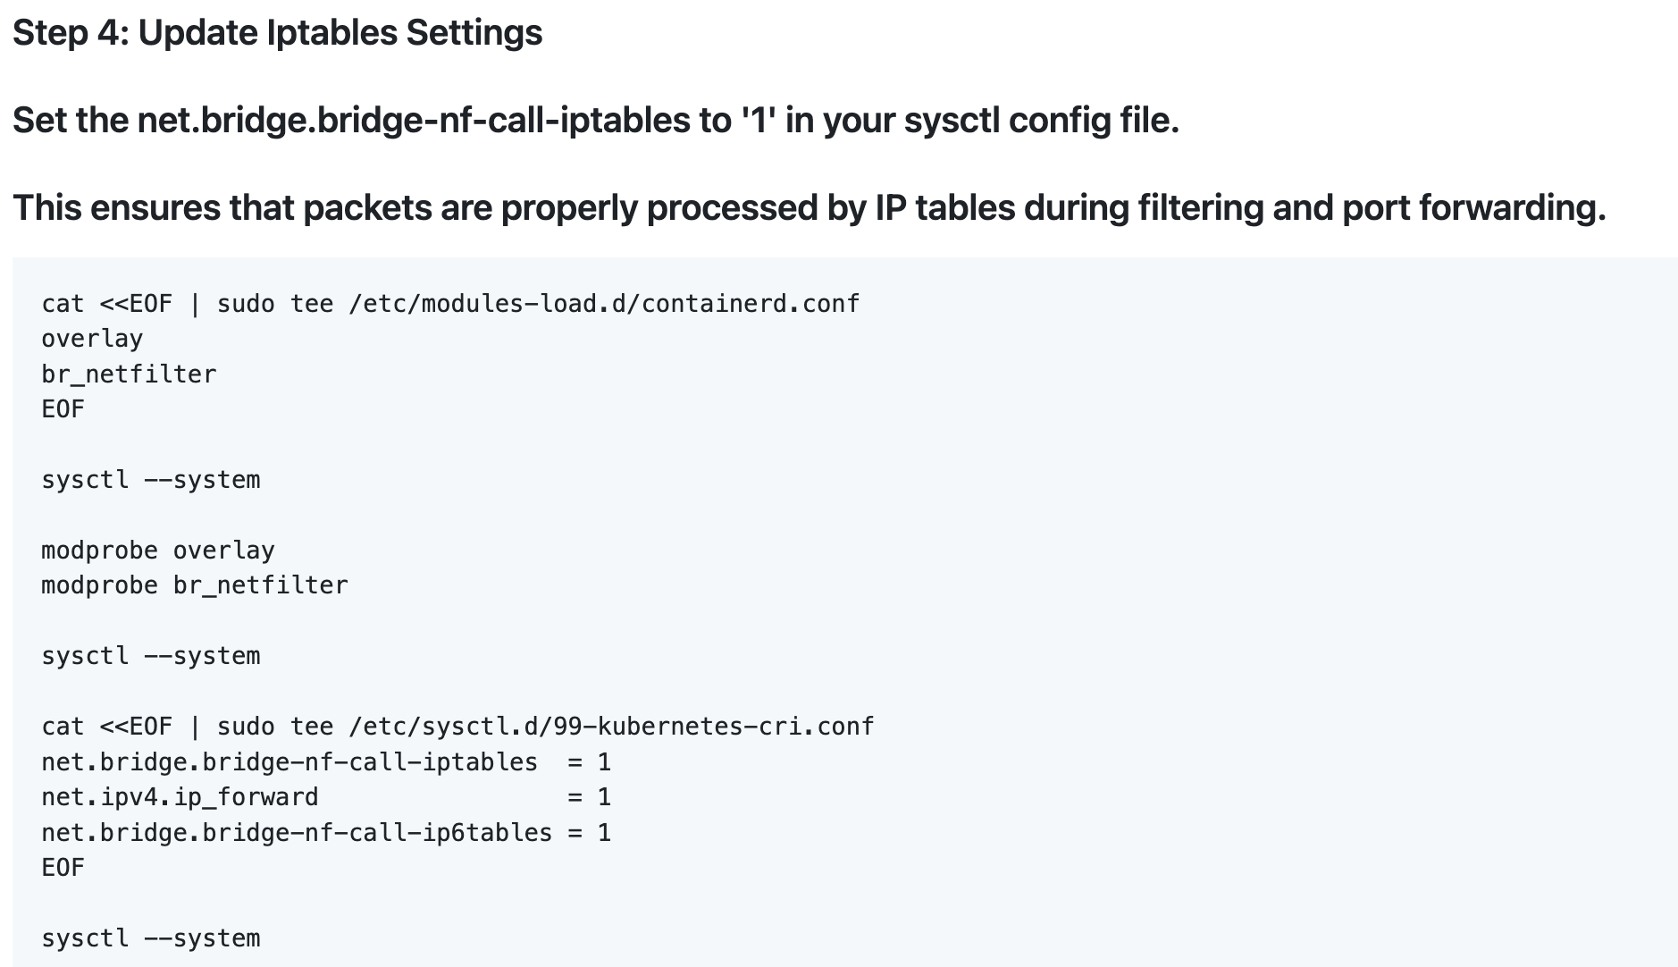

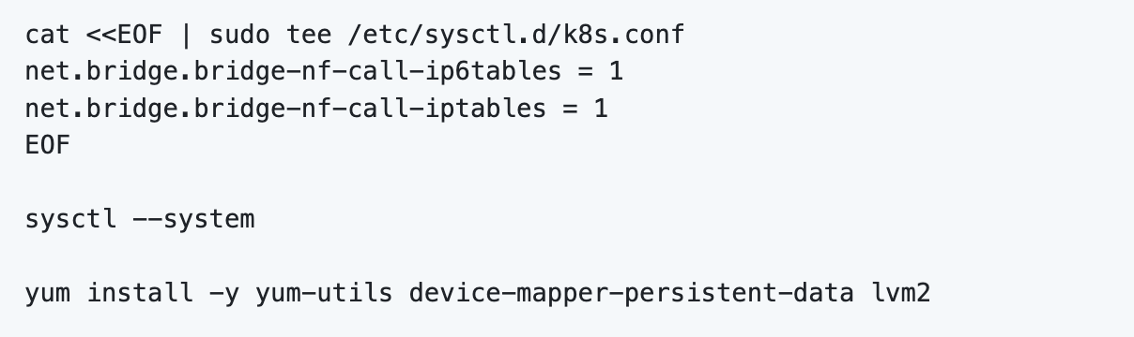

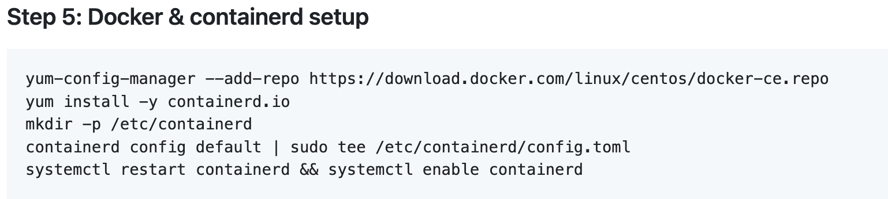

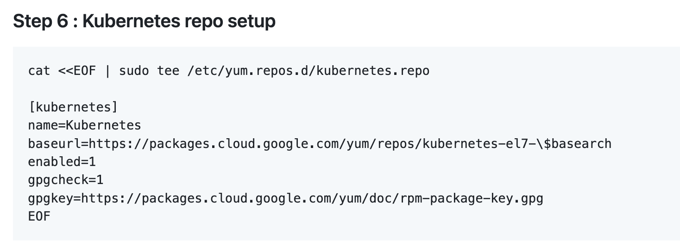

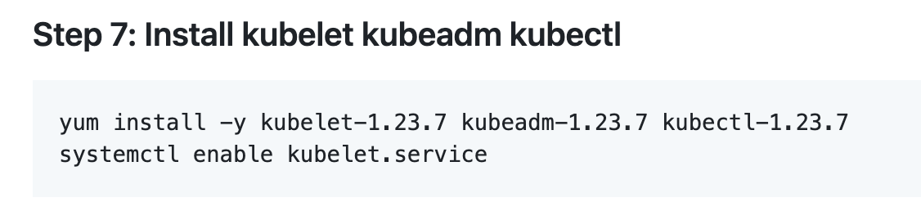

Note: Above all steps have to be done on both master and worker node.

**Below steps only on Master:**

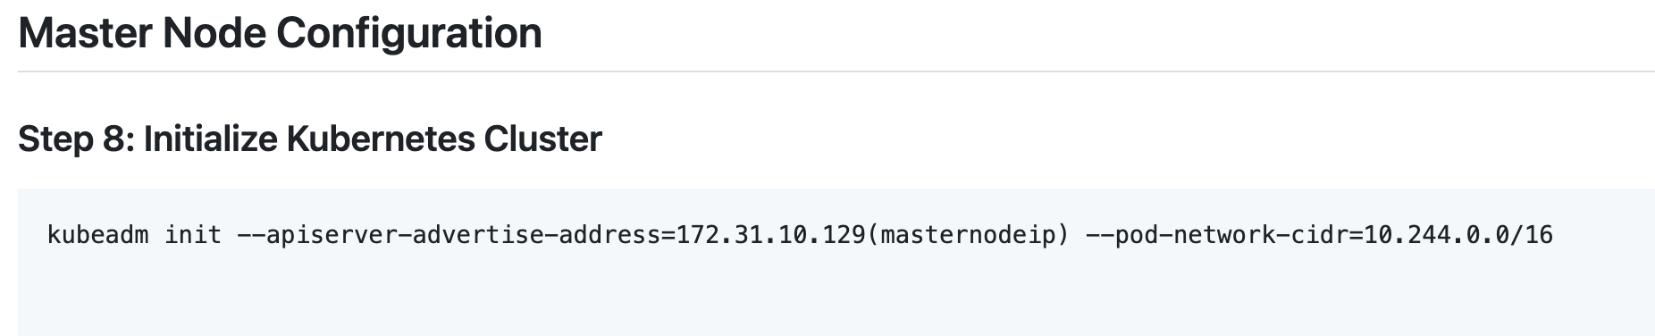

Incase you have some error w.r.t to cni run the below command again



Note: You will get a token kubeadm join …..

Copy that, you would need to paste that in worker node in coming steps

Switch to Centos User and run below commands

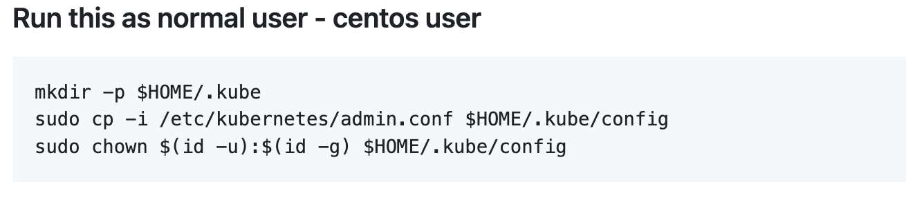

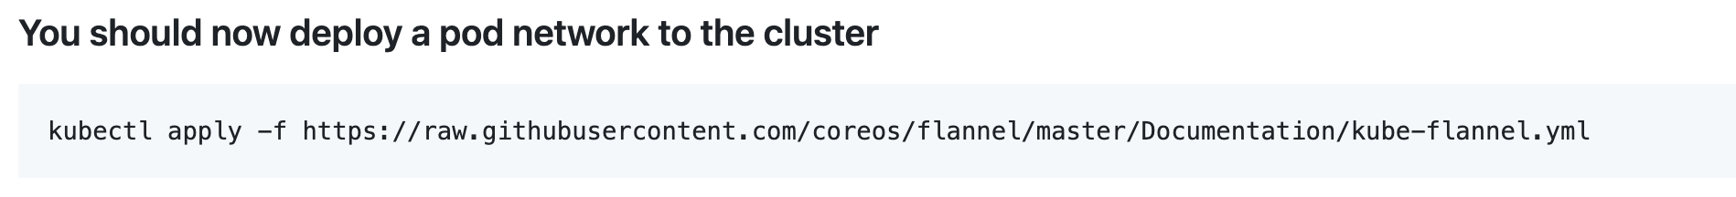

**Run the below command on Worker node**

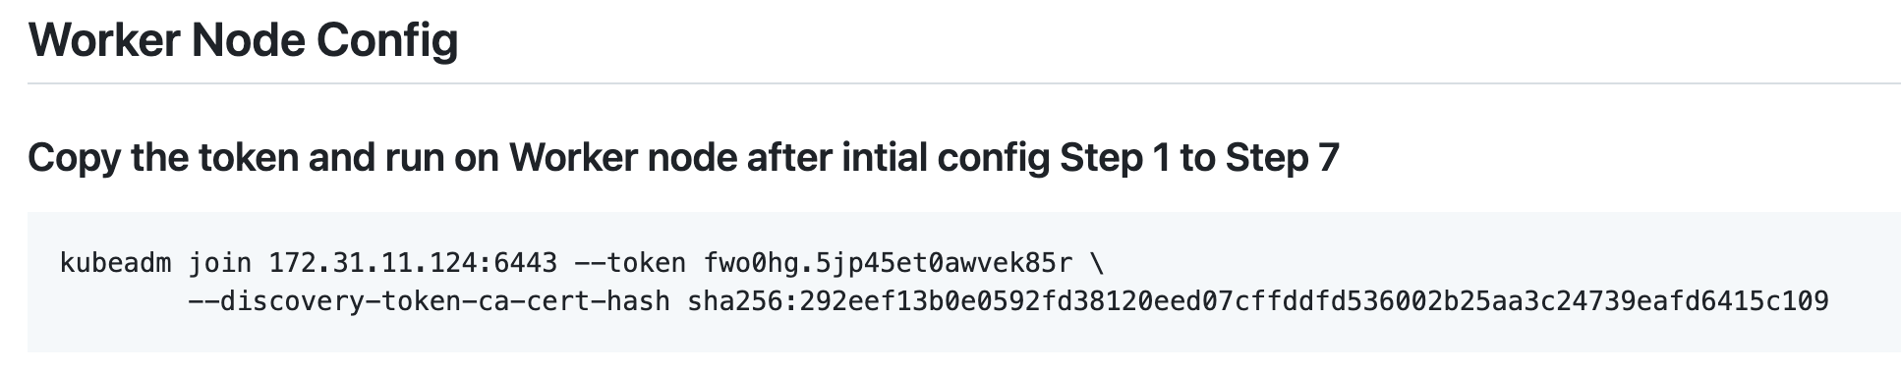

**Note:** above is the sample kubeadm join token, remember you need to paste the token code, which you get from master node after initializing Kubernetes cluster

Incase you face any error w.r.t cni, run below command and re-run kubeadm join



Installation is now complete. Go to master node and type command from centos user

kubectl get nodes

—----------------------------------------------------------------------------------------------------------------------------